PRMS Documentation
Demo Fontend (React js)
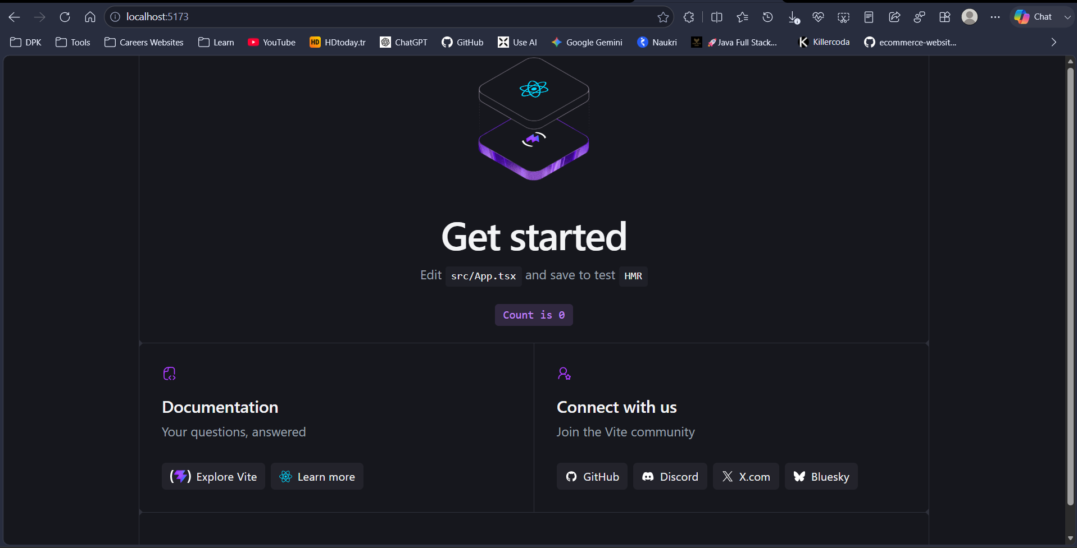
Demo Backend (Spring Boot)
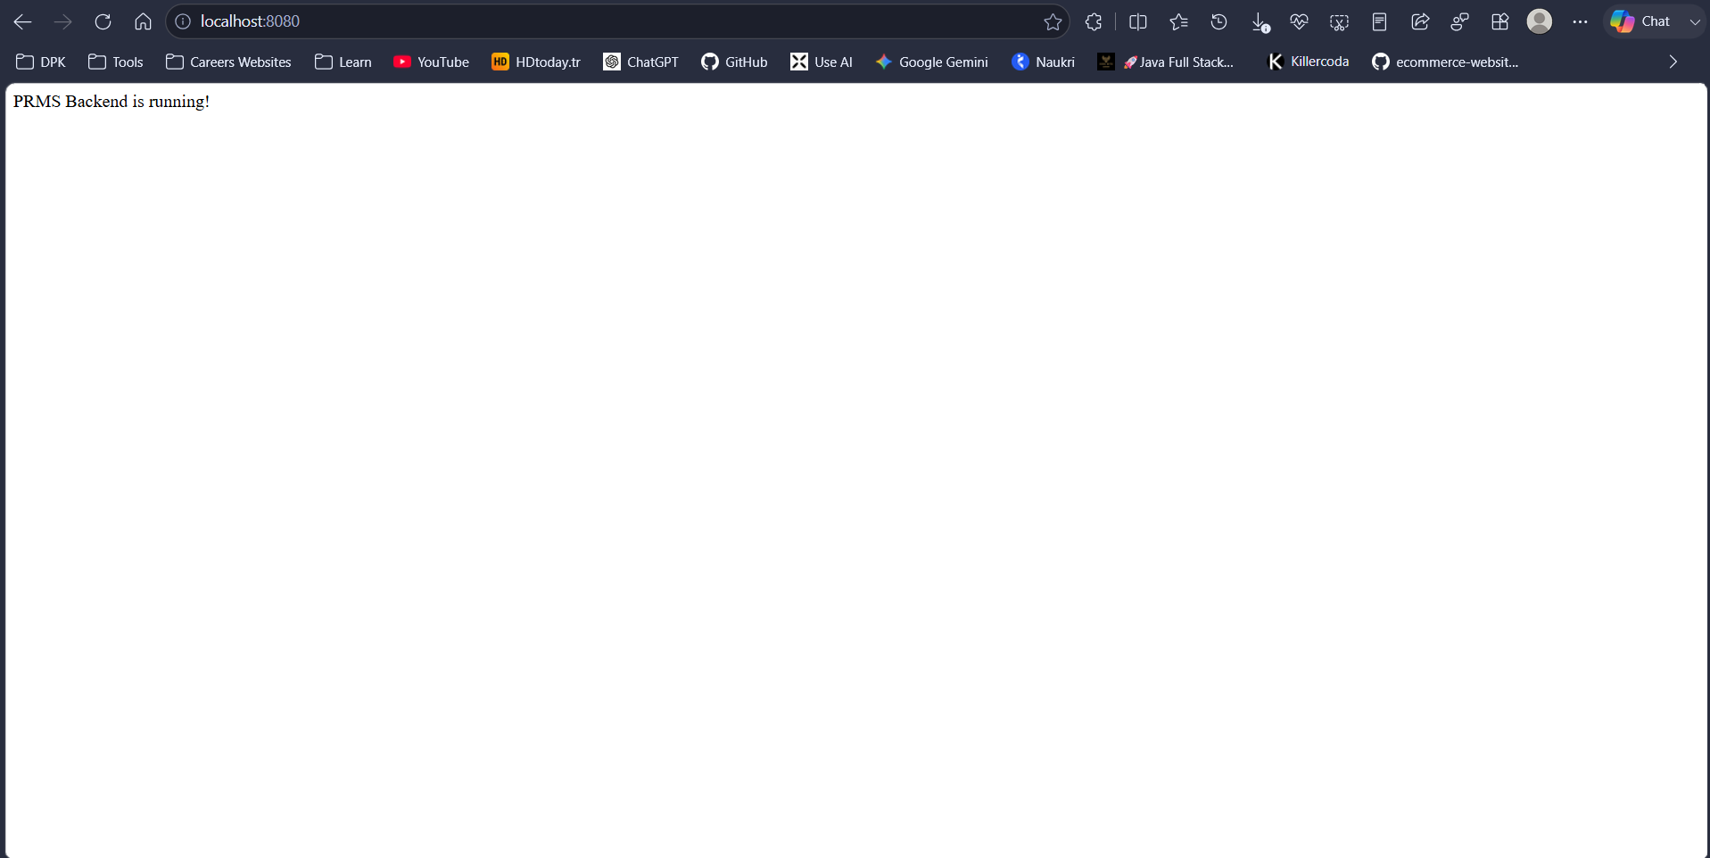
Demo database (Mysql)
